Option #2: Installing Python and Running

A Data Set Visualization and Graphing in PyCharm Edu Program

Brett M. Amione

Colorado State University – Global Campus

Below are two screenshots of the code entered into JetBrains PyCharm Edu. Figure-1 shows the code from lines 1-45 and Figure-2 shows lines 45-68.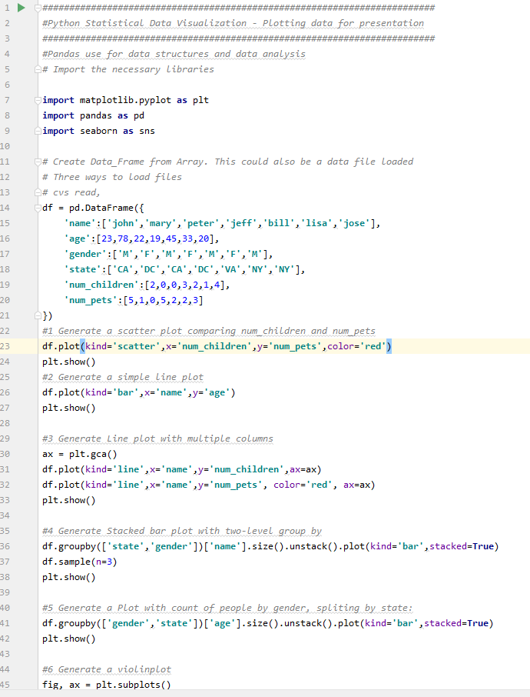

Figure 1

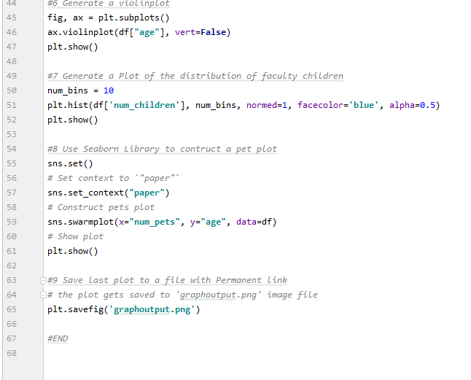

Figure 2

After running the program, the “run window” displayed exit code 0 as seen in Figure-3. 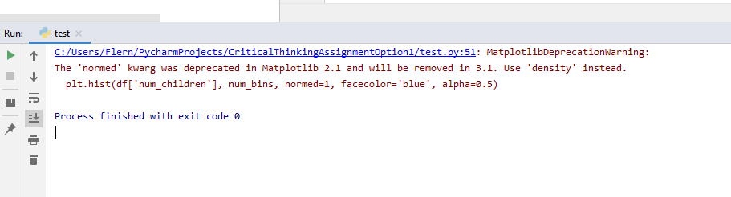

Figure 3

The results of this program are the creation of 8 visualization tools

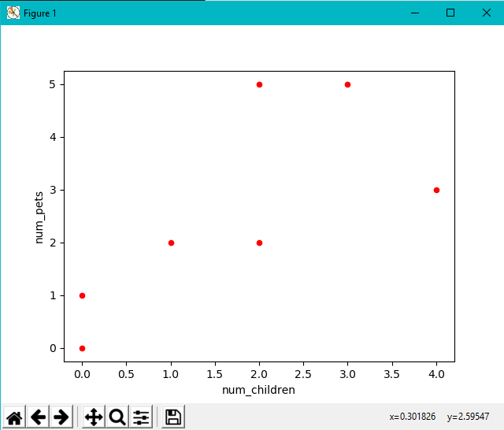

Figure 4: Scatter Plot Comparing Number of Children to Number of Pets

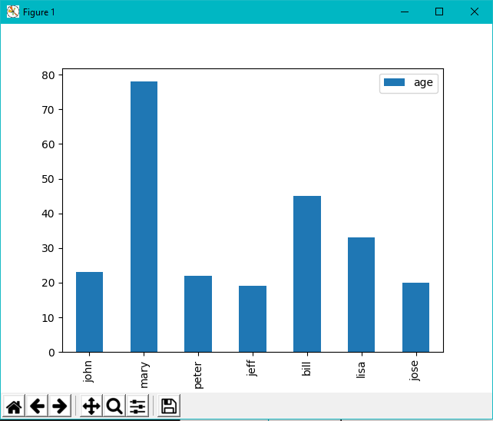

Figure 5: Bar Plot Showing Peoples’ Names and Ages

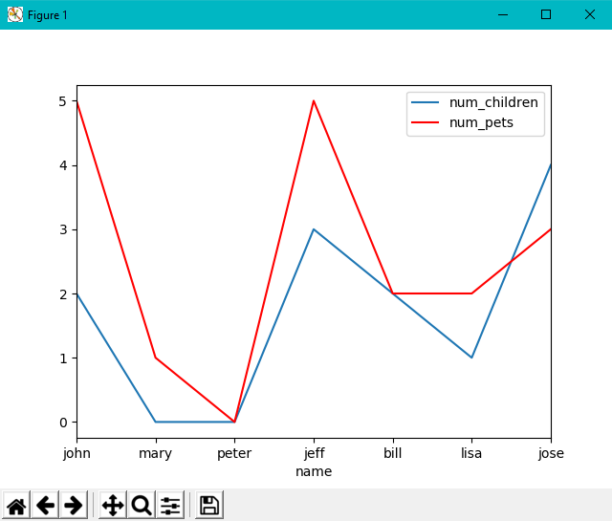

Figure 6: Multi-Line Plot Comparing the Number of Pets and Number of Children Each Person Has

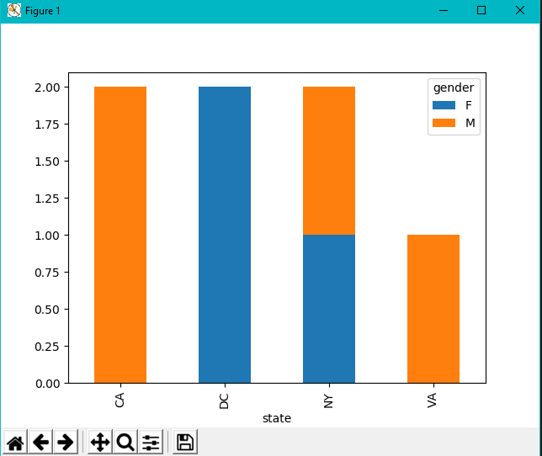

Figure 7: Stacked Bar Plot Displaying Gender Composition by State

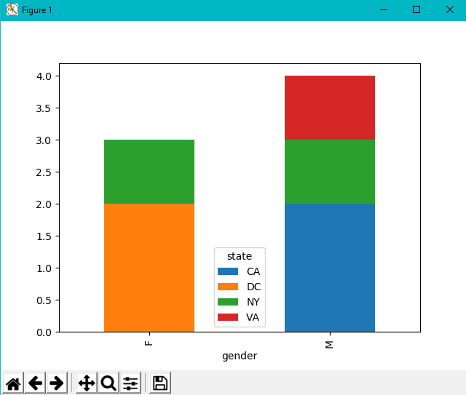

Figure 8: Stacked Bar Plot Comparing Number of Males and Females by State

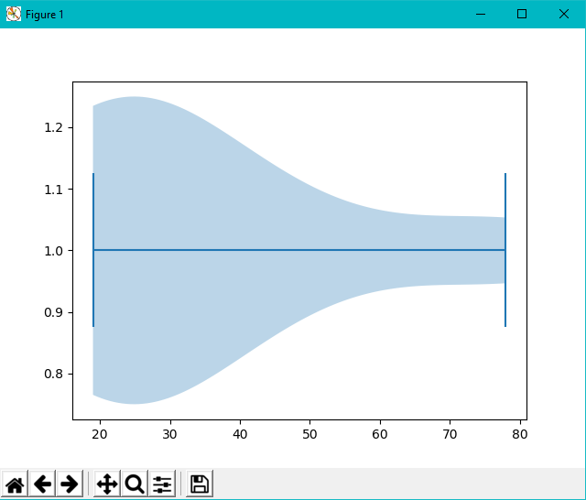

Figure 9: Violin Plot Showing Amount of People per Age

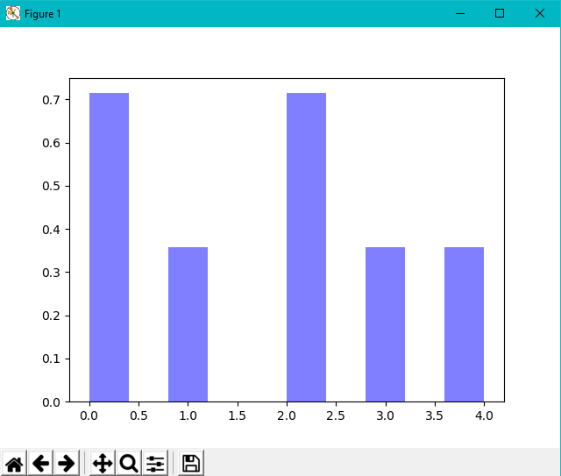

Figure 10: Histogram Showing Distribution of Faculty Children

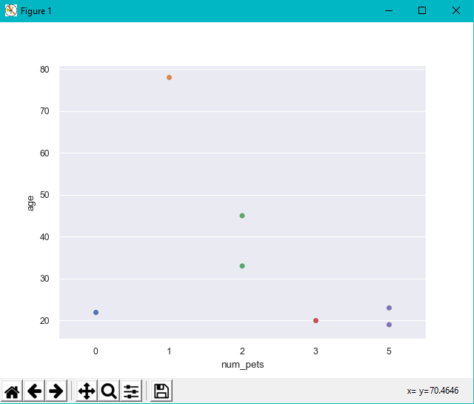

Figure 11:Swarm Plot Showing Number of Pets Compared to Age of Owner

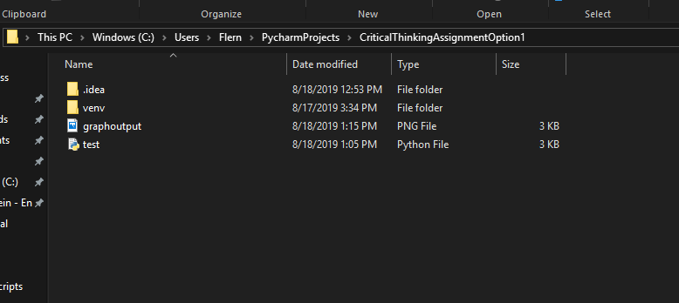

Figure 12:PNG Output of Swarmplot